**Project Deliverable 3 – User Manual**

**Faculty Name:** Information Technology

**Module Code:** ITECA3-B12

**Module Name:** Web Development and e-Commerce

**Content Writer:** Kariboba Mpwampu

**Copy Editor:** Mr Kyle Keens

**Submission Date:** Block 2 Week 5

|  |  |
| --- | --- |
| **Student Name** | Lea Thumbiran |
| **Student Number** | LMTPQFTH6 |
| **Project Title** | Lights Out Loadshedding E-Commerce Website |
| **Submission Date** | 11 June 2023 |

**Table of Contents**

3.1 Introduction 1

3.2 Basics: Accessing your website and Admin 1

3.3 Products: Adding, removing, and updating products 5

3.4 Shipping Options 9

3.5 Orders 9

3.6 Updating a page on your site 10

3.7 Collecting money from the store 10

3.8 Checking Web Traffic and Statistics 11

3.9 Appendix 13

# Introduction

**3.1.1 Background**

Lights Out is a small online business that provides products to deal with the effects of load-shedding. This user manual serves as a guide to customers and administrators on how to set up the website and database, access the website, manage products, manage blog posts, manage orders, manage shipping rates as well as how to monitor web traffic and statistics.

**3.1.2 About this website.**

The following tools and technologies used for this e-commerce website were:

* **HTML (Hypertext Markup Language)** – this is used by web developers to structure and present each of their web pages.
* **CSS (Cascading Style Sheets)** – this is used for controlling the layout, design, and the appearance of each web page on the website.
* **JavaScript** – this is a programming language that is responsible for handling animations, performing client-side validation, and enabling dynamic behaviour on the website.
* **PHP (Hypertext Preprocessor)** – this is used for creating web pages that are dynamic as well as enable web applications to interact with databases.
* **SQL (Structured Query Language)** – this is used to manage relational databases. It can be used to execute tasks such as retrieving, deleting, updating, and inserting data in a database.
* **000webhost** was used to host the website and it provided its own online database.
* **Logo.ai** was used to generate the logo for the website.

# Basics: Accessing your website and Admin

**3.2.1 Accessing the website.**

Both the customer and the administrator will use the same links to access the website.

**The link to the home page is:** [**https://lights-out-south-africa.000webhostapp.com/index.php**](https://lights-out-south-africa.000webhostapp.com/index.php)

The home page is shown below:

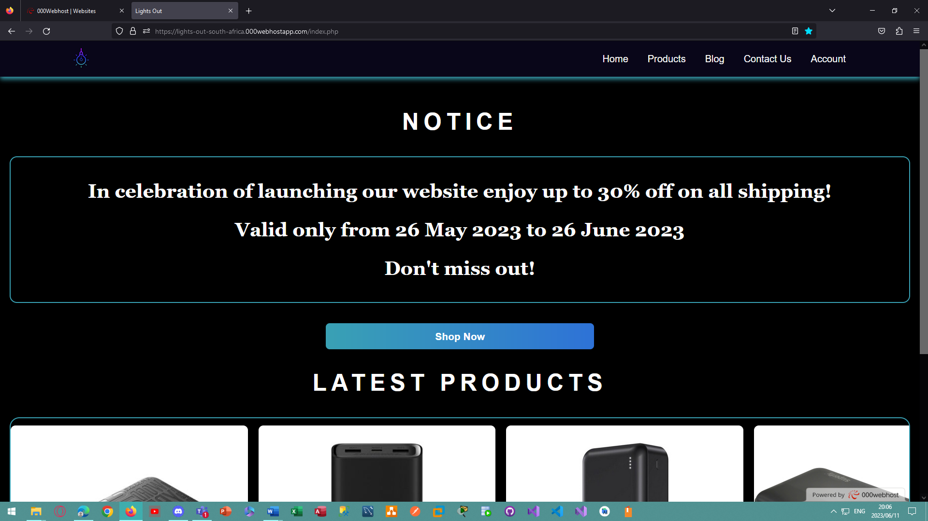

*Figure 1 - Home Page for The Lights Out E-Commerce Website.*

Afterwards, both the customer and the administrator can click on Account in the top right corner of the screen to log into the website. The login page is shown below:

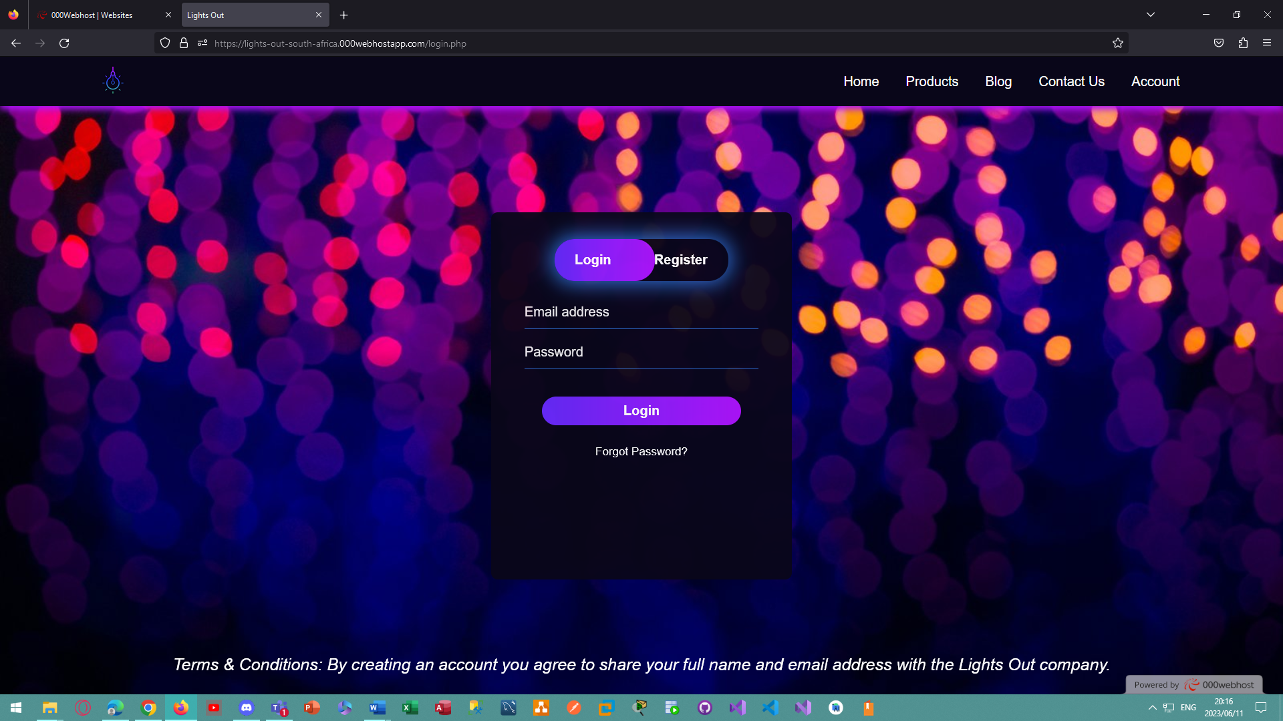

*Figure 2 – Login Page for The Lights Out E-Commerce Website.*

After the customer and the administrator have logged in, the website will display the web pages dynamically based on what type of user (such as a customer or administrator) logged in.

**3.2.2 The Admin Area**

Administrators do not have their own separate dashboard on this website, instead when they log in, they are taken to the same account page, products page, and blog posts page as the customer. While they are taken to the same pages administrators can manage (add, update, and remove) products and blog posts as well as update their own account details.

The account page is shown below:

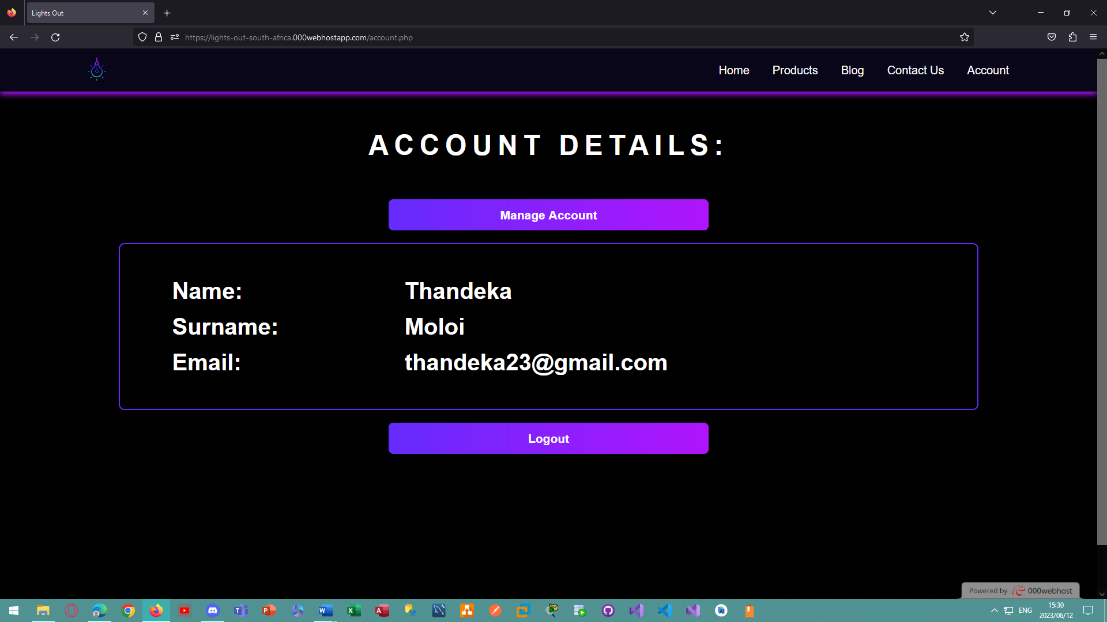

*Figure 3 - The Account Page for Administrators for The Lights Out E-Commerce Website.*

The products page is shown below:

*Figure 4 - The Products Page for Administrators for The Lights Out E-Commerce Website.*

The blog posts page is shown below:

*Figure 5 - The Blog Posts Page for Administrators for The Lights Out E-Commerce Website.*

# Products: Adding, removing, and updating products

**3.3.1 Adding and Removing Products**

Administrators can add and remove products directly on the website.

**The steps to add a product are as follows:**

1. Log in as an administrator.
2. In the menu at the top of the page click **Products**. The button to add products is displayed at the top of the page. This is shown below:

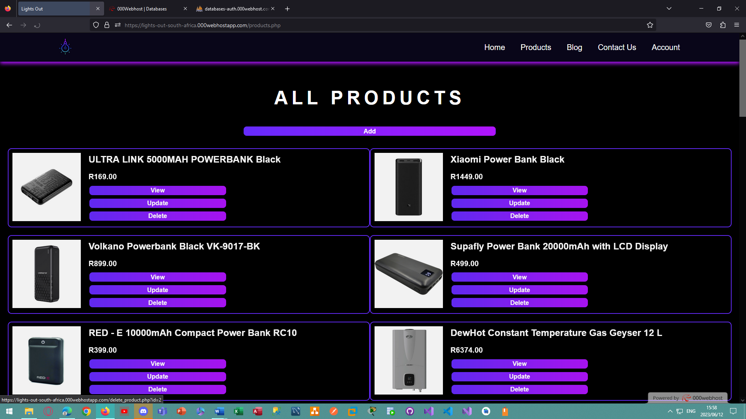

*Figure 6 - The Products Page for Administrators for The Lights Out E-Commerce Website.*

1. Click on the **Add** button. It will open the add product page. This is shown below:

*Figure 7 - Add Product Page for Administrators.*

1. Fill out the add product form with the name of the product, a description of the product, the price of the product and the location of the product image.
2. Click on the **Add Product** button to save the product.
3. The newly added product will appear on the **Products** page.

**The steps to remove a product are as follows:**

1. Log in as an administrator.
2. In the menu at the top of the page click **Products**. This is shown below:

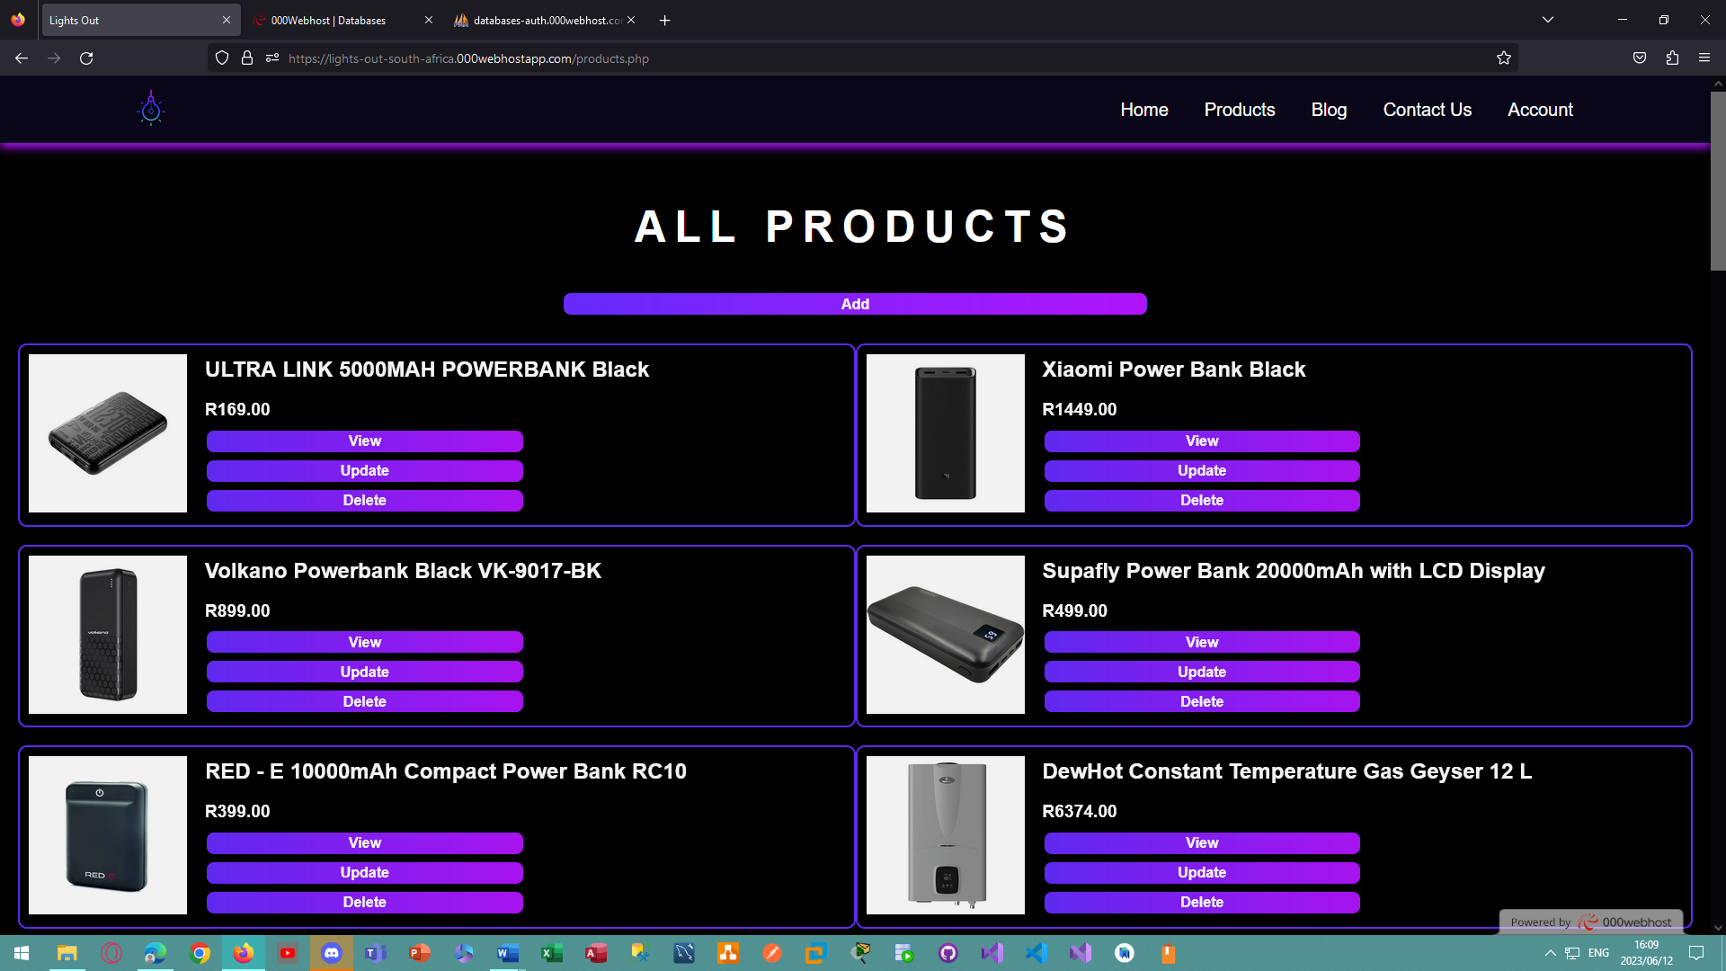

*Figure 8 - The Products Page for Administrators for The Lights Out E-Commerce Website.*

1. Scroll down and locate the product that you wish to remove, then click the **Delete** button.
2. A message will pop up asking if you want to delete the product, click **OK**.
3. The product has now been removed from the website.

**3.3.2 Updating Products**

**The steps to update a product are as follows:**

1. Log in as an administrator.
2. In the menu at the top of the page click **Products**. This is shown below:



*Figure 9 - The Products Page for Administrators for The Lights Out E-Commerce Website.*

1. Scroll down and locate the product that you wish to update, then click the **Update** button. It will open the update product page. This is shown below:

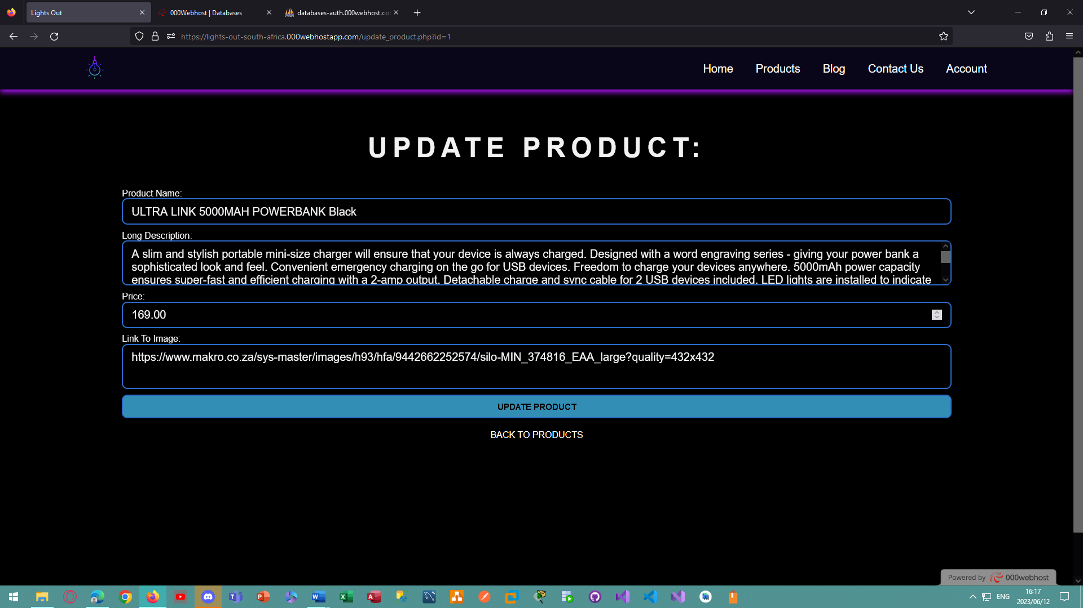

*Figure 10 - Update Product Page for Administrators.*

1. Update the product details.
2. Click the **Update Product** button.
3. The product has now been updated on the website.

# Shipping Options

Currently, all shipping will have a flat rate of R75 for the first few months. Afterwards, the shipping rate will be based on where the customer is located.

# Orders

After customers place an order, a reference number is generated and stored in a database table named **reference_numbers**. This is shown below:

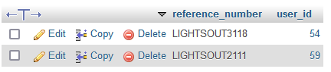

*Figure 11 - Reference numbers for customer orders.*

The reference number, the total of the order, the cost of shipping and the date of the order are stored in another database table named **orders**. This is shown below:

*Figure 12 – Customer Orders.*

The details of each order such as the order id, names of the product, the quantity selected, and the price of each product are stored in another database table named **order_details**. This is shown below:

*Figure 13 - Customer Order Details.*

Administrators should use these tables to process and track the customers’ orders on the website.

# Updating a page on your site

Currently, new pages cannot be added to this website.

Existing pages such as the products and blog posts page are updated automatically when administrators add and remove products and blog posts on the website.

# Collecting money from the store

This website uses Electronic Fund Transfers (EFT). The bank account details are provided on the checkout page when a customer places an order, this is shown below:

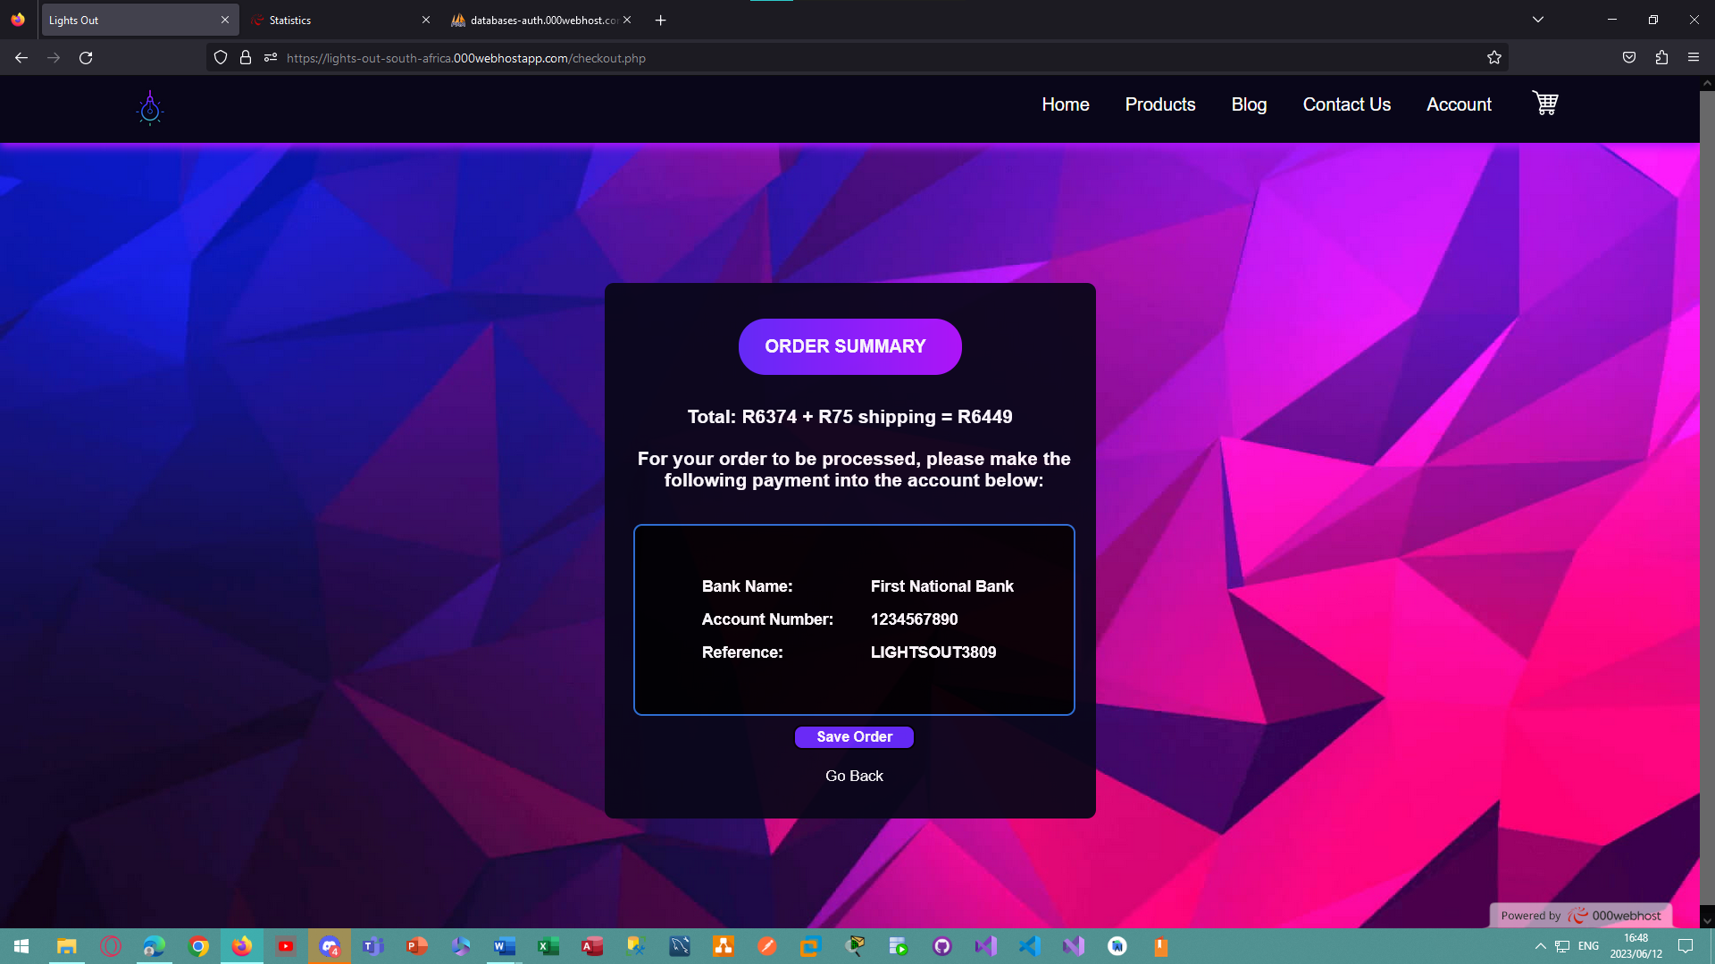

*Figure 14 – Bank Account Details for the Lights Out E-Commerce Website.*

Once a customer places an order, the order is saved, however, the order is only processed once a payment has been made into the bank account shown above. Once the payment is made, the order will take a few days to be processed.

# Checking Web Traffic and Statistics

This website utilizes 000webhosts’ built-in dashboard to monitor web traffic and statistics.

This is shown below:  
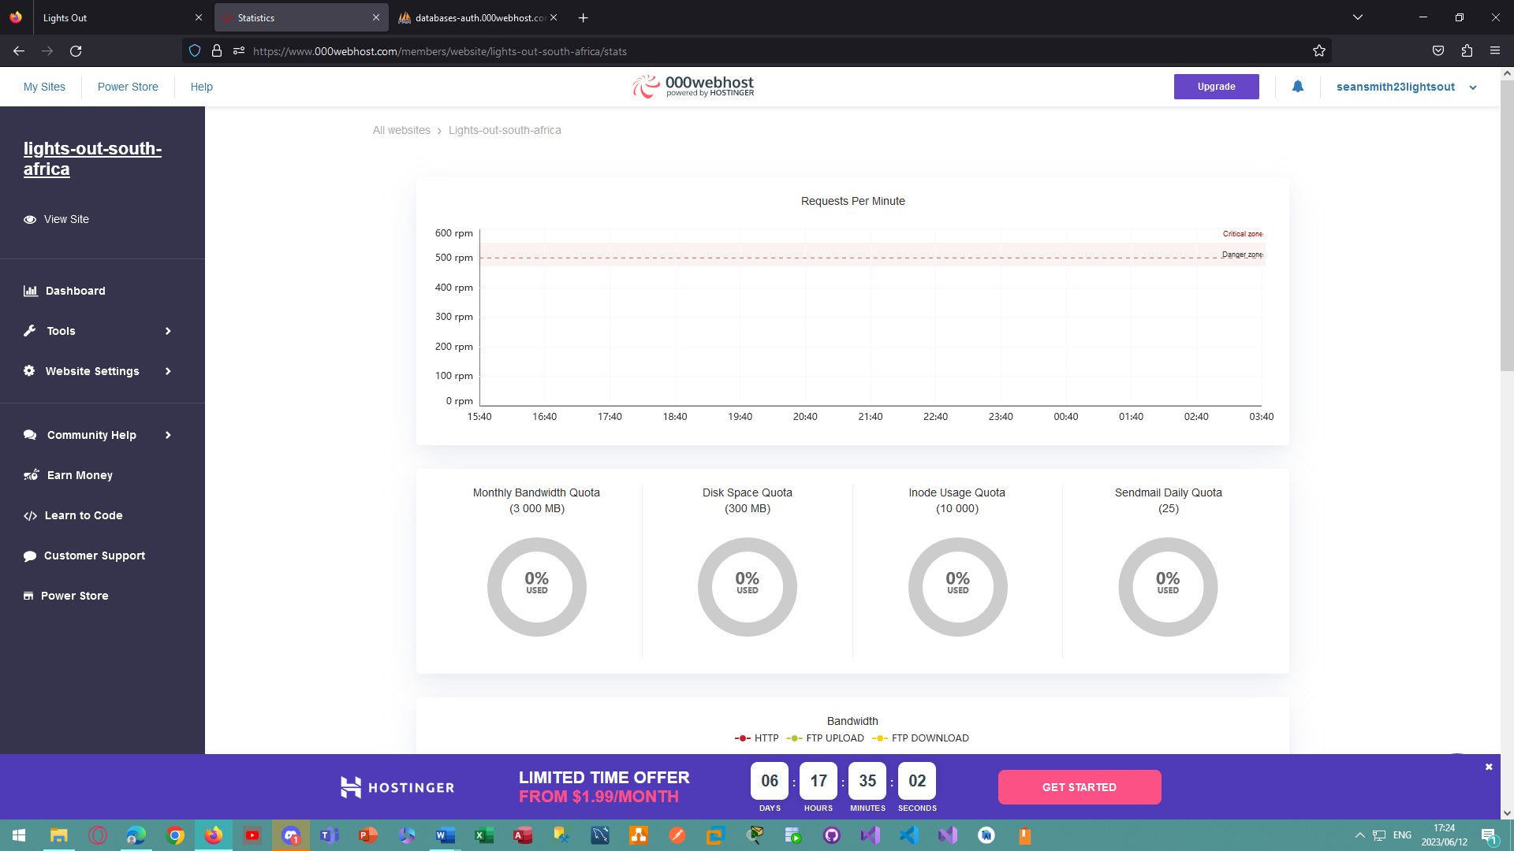

*Figure 15 - Checking how many requests were made per minute.*

*Figure 16 – Checking the bandwidth used and the response codes generated.*

*Figure 17 - Checking how long requests took to be processed and how many emails were sent using 000webhosts' built in email sender.*

# Appendix

**The steps to set up the website are as follows:**

1. Download the attached zip file named **lightsout**. This file contains all the code for the website.
2. Open your web browser and paste the following URL: <https://www.000webhost.com/>
3. Create an account.
4. Sign into your account.
5. Click on **Add a new website**.
6. Give the website a **name**, such as **lights-out-south-africa**.
7. Click on the **dashboard**, scroll down, and **click** on **file manager**.
8. The file manager will open in a new window.
9. In the **file manager**, click on the **public_html** folder.
10. **Delete** the **.htaccess** file.
11. Drag the **lightsout** zip file into the browser window and **click upload**.
12. Open a new browser window and paste the following URL: <https://github.com/ndeet/unzipper>
13. **Download** the zip file.
14. **Extract** the zip file.
15. **Select the contents of the file** that was downloaded and **drag it into the browser window** that has the **file manager** open.
16. Click **upload**.
17. Go back to your **dashboard**. On the left-hand side, click on the URL that has the name of the website, for example, <https://lights-out-south-africa.000webhostapp.com/index.php>
18. Click in the area where the URL is and change the end of the URL to: <https://lights-out-south-africa.000webhostapp.com/unzipper.php>
19. Click on **extract**.
20. Go back to the **file manager** and **refresh** the page. The **lightsout** file has now been extracted.
21. Select all the contents of the **lightsout** file and click **move**, move the contents into the **public_html** file.
22. In the **public_html** file, in the top right corner of the screen, click **add file**.
23. Name the file **.htaccess** and paste the following line into the folder:

**php_flag output_buffering on**

1. Click **save**.
2. Go back to the **dashboard** and click on the URL for the website, the website should now display in the browser window.

**The steps for creating and connecting to the database are as follows:**

1. Open **000webhost** and click on the **dashboard**.
2. Scroll down and click on **phpMyAdmin**.
3. Click **Create a new database**.
4. Provide a **name** for the database, for example, the name could be **lights_out.**
5. Provide a **password** and **username** for the database.
6. Click **save**.
7. **Open** the **database**, it will display in a new browser window.
8. On the left-hand side, click on the **lights_out** database to expand it.
9. In the middle of the screen in the menu click on **SQL**.
10. ) Inside the **lightsout** folder that you downloaded previously click on the **Database Scripts** folder.
11. ) **Copy and paste** the **contents** of the **vendor.sql, feedback.sql, blog_post.sql, cart.sql, cart_products.sql, orders.sql, order_details.sql, products.sql, reference_numbers.sql and the users.sql** files **into the browser window** that has the database.
12. ) Scroll down and click **go**.
13. ) The database tables will be created, and any existing data will be inserted into the tables.
14. ) Open **000webhost**, click on the **dashboard** and open **file manager**.
15. ) In the **public_html** file, locate the **db_config.php** file.
16. ) Open the **db_config.php** file.
17. ) **Edit** the **database name**, **username** and **password** with the details used to create the database (this can be found in steps 4 and 5.)
18. ) **Save** the file.
19. ) Open the **website** again, now the products, logo, and other relevant data will be loaded.